Expedia

Reference link: graphql

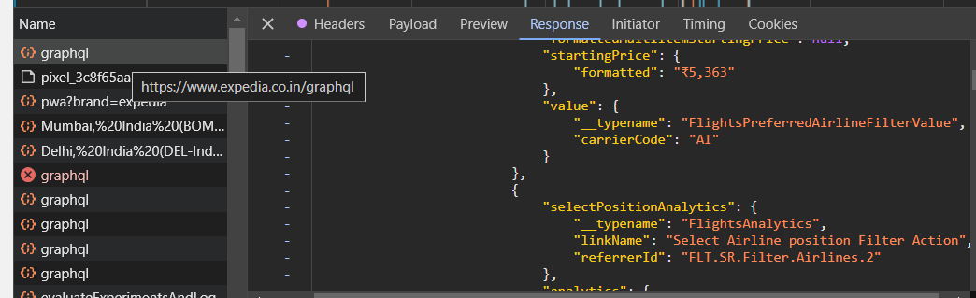

Booking.com

Reference link: flights: all flight

Min: min prices

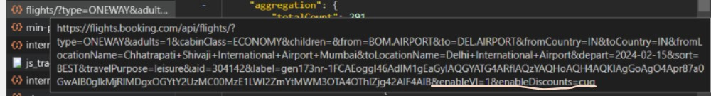

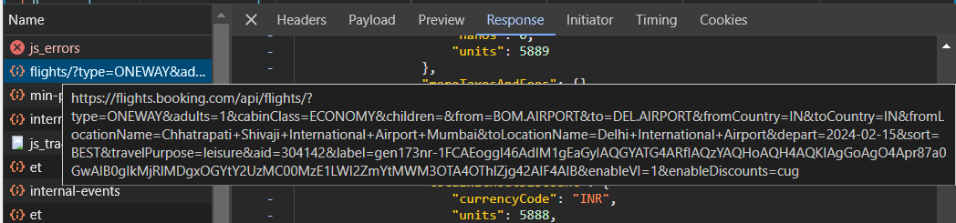

Priceline:

Reference link name: pcln-graph/

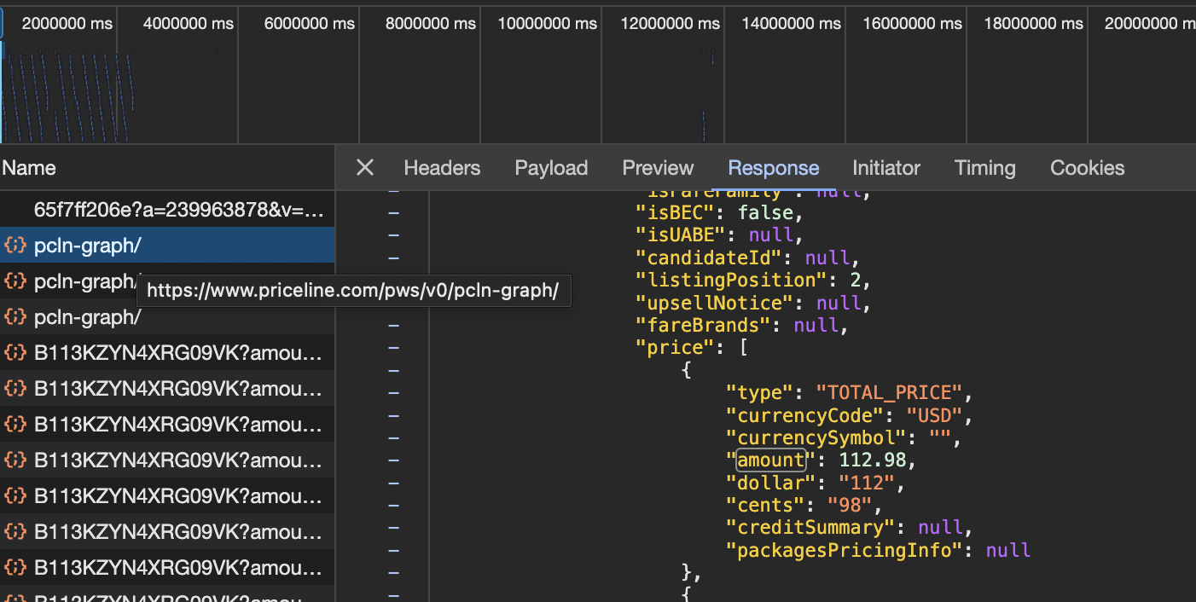

Hopper:

Reference link name: shopSummer

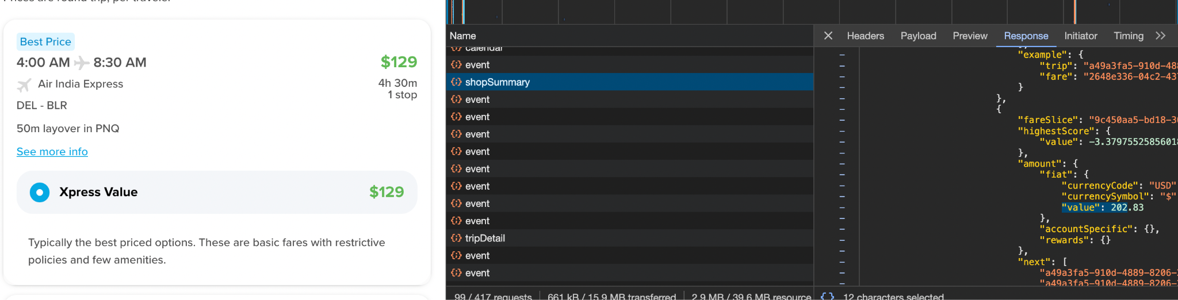

SkyScanner( For Initial Understanding):

Reference link name: search

